**PROJECT NAME:**

**Design and Analysis of Algorithms Deliverable 2**



**GROUP MEMBERS:**

**Student Name Roll Number SECTION**

**Abdul Ahad 22k-4221 BCS-5G**

**Daaim Ali 22k-4363 BCS-5G**

**Sohaib Baig 22k-4204 BCS-5G**

**_____________________________________**

Theory Teacher SIGNATURE & DATE

**Course Title: Design and Analysis of Algorithms**

**Course Code: CS2009**

**Submitted to Miss Anaum Hamid**

Q2

i) 10 Sample input text files with 101 coordinates each, created using the generate_cpp_sample_input.py script attached with submission

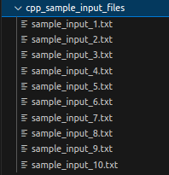

Example sample input file:

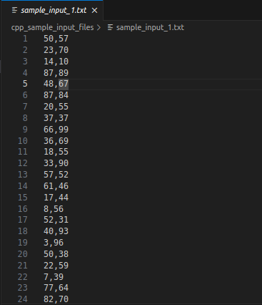

ii) 10 Sample input text files with 101 8-bit binary integers each, created using the generate_karatsuba_sample_input.py script attached with submission

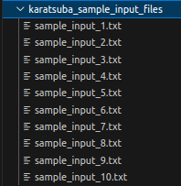

Example sample input file:

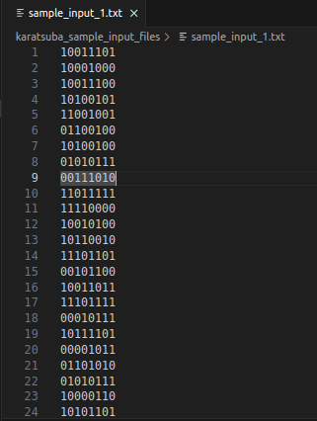

Q3 & 4

Python Streamlit library UI:

* Install python dependencies, run the following command when inside the same directory as the requirements.txt file:

**pip install -r requirements.txt**

i) Closest Pair Points Algorithm

* command: **streamlit run cpp.y**

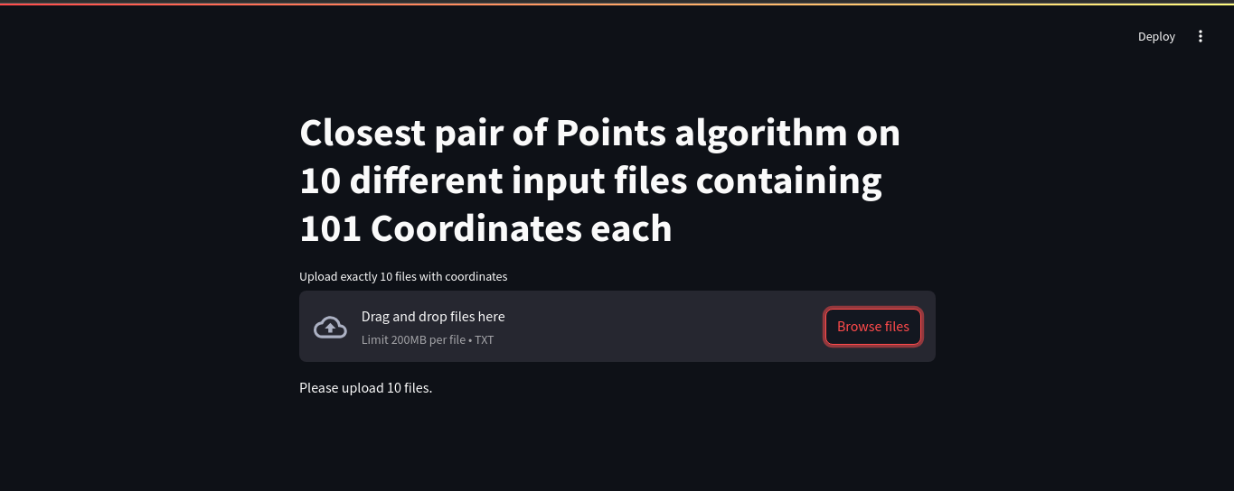

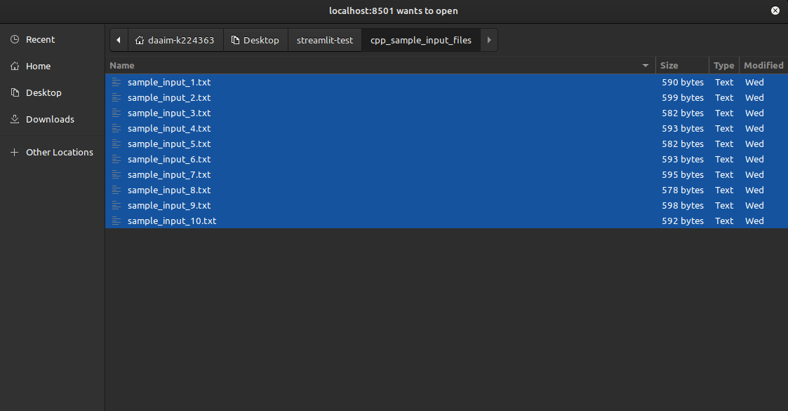

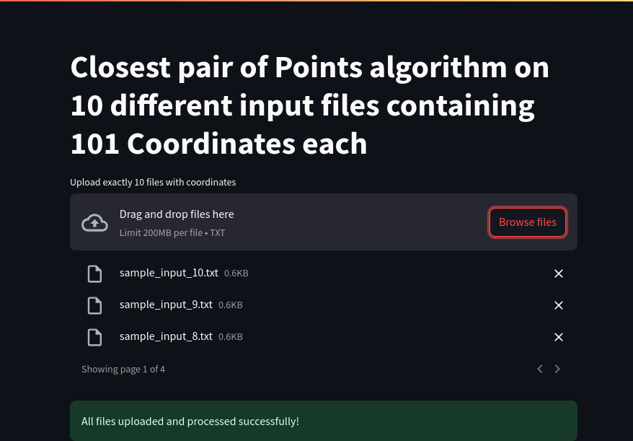

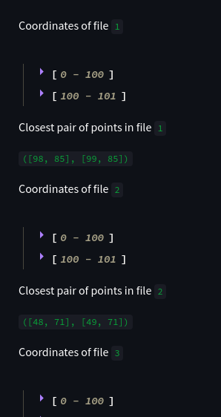

ii) Karatsuba Integer Multiplication Algorithm

* command: **streamlit run karatsuba.py**

